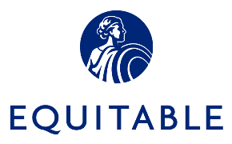

Facebook AD Template


r Outlook Signature:
Overview

Equitable Advisors Financial Professionals (FPs) and authorized branch personnel who are interested in utilizing Facebook for business purposes may do so by enrolling in Equitable Advisors Marketing Suite and Proofpoint Patrol. Proofpoint Patrol is our third-party vendors that has been engaged by Equitable to assist us in addressing applicable company policy and existing regulatory obligations and compliance requirements. Proofpoint Patrol is the platform that permits Equitable Advisors to monitor FP activity, conduct Facebook message surveillance and archive all content posted to the business page.
Financial Professional and authorized branch personnel Facebook business pages must be approved by Regional Compliance prior to being posted on Facebook or otherwise made public, and their content will be subject to revision during this process. Facebook Ads may only be posted via a Facebook business page that has already received compliance approval and is connected to Marketing Suite & Proofpoint Patrol.
Advertising Compliance Submission Procedure
IMPORTANT: Unlike Facebook business pages, which are subject to branch approval, Facebook ad templates are subject to Advertising compliance (AdC) approval. When submitting your ad template on AdTrax, be sure to choose “Other” from the Type of Material dropdown, then write “Facebook Ad Template” in the “Please explain:” open field provided. Do NOT choose “Facebook profile” from the Type of Material dropdown when submitting a Facebook Ad Template as this will incorrectly route the submission to the Branch, which will then have to be withdrawn and closed without approval so that a new submission can be made and correctly identified as “Other: Facebook Ad Template”.
Additionally, posted profile content may be subsequently removed or flagged for revision by AdC and/or broker-dealer surveillance procedures using Proofpoint Patrol’s filtering and moderation capabilities. In addition to compliance requirements, all social media activities must comply with Equitable’ s code of ethics, anti-discrimination and anti-harassment policies. Equitable Advisors Financial Professionals and branch personnel must respect the privacy of their clients and prospects and may not refer to the company’s vendors in public forums.
The information on the template below may not be posted to Facebook Business Page until it is approved by Advertising compliance.

Business use of any new features on Facebook business pages is prohibited until Equitable Advisors expressly approves the new feature.
Please use the template below to compose your Facebook Ad. The information below may not be posted to Facebook until it is approved by Advertising Compliance.

For more information click here: https://www.facebook.com/business/help/1498697080353950

Please Note: Facebook limits the number of characters for certain fields. It is the responsibility of the FP to ensure that the information provided below fits within the allotted character limits. Advertising Compliance reviews for content only.
Template

URL
Add your Equitable Advisors compliance approved website
Format
Add the image(s) you'd like to use in this ad. Please use a larger image. Minimum Size: 254 x 133 pixels Recommended Size: 1,200 x 628 pixels. Videos are prohibited. You may use the Free Stock Images so long as they are appropriate for your ad, and are not promissory, exaggerated or offensive. If you use someone else’s picture, please make sure you have the signed photo release form on file.
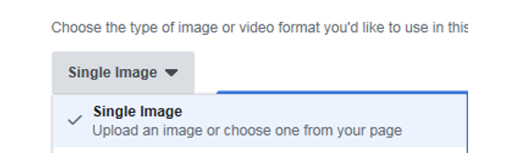
Headline
Add a headline that grabs people's attention and tells them what your ad is about. If you’re hosting a seminar, you would use the Presentation Title here.
Text  Tell people a bit more about your Ad. Make sure to clearly explain what you're promoting. Remember it cannot be promissory, exaggerated or outside your role at Equitable Advisors. | Text here-  Equitable Advisors, LLC (NY, NY 212-314-4600), member FINRA, SIPC. (Equitable Financial Advisors in MI & TN). // Equitable Network, LLC. AGE-xxxxxx(xx/xx)(Exp.xx/xx)  or other disclosures determined by AdC during review.
Call to Action
Choose the action you want people to take when they see your ad

Applicable options are: Contact Us, Learn More & Request Time. Download may be allowed depending on the overall Ad and what will be downloaded (company approved piece). AdC discretion. All others are not allowed. You must show where your selection will link to and what information we are obtaining from the viewer. Remember, we should not be linking to 3rd party landing pages.
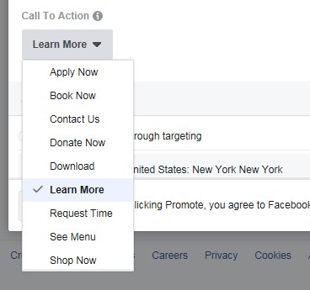

People you choose through targeting: | - Country: United States [must select]  - By State/Province:  - By City:  - Use your Facebook Page location to reach people near your business:
Detailed Targeting
Define your audience by including or excluding demographics, interests and behaviors
Facebook will determine your approximate audience size
Two options to choose: | - Run this add continuously  Your ads will run continuously for a daily budget. This option is recommended. For more info click here https://www.facebook.com/business/help/190490051321426  - Daily budget:
- Choose when this ad will end
- Daily budget:
- Duration:
- Run this ad until:

* For all Non-English Ads:
Following the ad’s full approval in English …
- A written translation certification must be by provided by a supervising registered principal who's willing to attest in writing (using the prescribed attestation below*) to his/her fluency in the language and to the accuracy of the translation. The reviewer's name and the date should be typed in English beneath his/her signature and date. The signed attestation must then be uploaded to the Facebook ad template’s AdTrax submission for final approval.
  - or –
- The Financial Professional can hire a professional translation service to provide the certification, which must then be uploaded to the Facebook ad template’s AdTrax submission for final approval.
- NOTE: as with most translated advertising and sales material, a brief disclaimer noting that future communications may be in English only will have to be accommodated in some form, and you’ll want to keep this in mind when designing and writing your ad.

*
I am a Registered Principal of Equitable Advisors, LLC. I have reviewed the attached [LANGUAGE] text and the English translation for [ACS NUMBER OF FACEBOOK AD TEMPLATE]. I certify that the English translation is, to the best of my knowledge, a true and accurate translation.

Additional Resources

READY TO LEARN MORE? ​
Visit our program microsite: www.equitable.fmgsuite.com ​
Contact FMG Support: Equitable@fmgsuite.com or (858) 500-5479​
Contact MarTech Project Team: AdvisorMartech@Equitable.com ​
​

