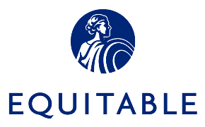

LinkedIn AD Template


r Outlook Signature:
Overview

Equitable Advisors Financial Professionals (FPs) and authorized branch personnel who are interested in utilizing LinkedIn for business purposes may do so by enrolling in Equitable Advisors Marketing Suite and Proofpoint Patrol. Proofpoint Patrol is our third party vendor that has been engaged by Equitable to assist us in addressing applicable company policy and existing regulatory obligations and compliance requirements. Proofpoint Patrol is the platform that permits Equitable Advisors to monitor FP activity, conduct LinkedIn message surveillance and archive all content posted to the business page.
Financial Professionals part of the Equitable Advisors Social Media Program who are interested in posting an Ad on LinkedIn must obtain prior approval from Advertising Compliance, and the content of the Ad will be subject to revision during this process.
Advertising Compliance Submission Procedure
Please use the profile template below to compose your LinkedIn Ad. The information below may not be posted to LinkedIn until it is approved by Advertising Compliance. When submitting your ad template on AdTrax, be sure to choose “Other” from the Type of Material dropdown, then write “LinkedIn Ad Template” in the “Please explain:” open field provided. Do NOT choose “LinkedIn profile” from the Type of Material dropdown when submitting a LinkedIn Ad Template as this will incorrectly route the submission to the branch, which will then have to be withdrawn and closed without approval so that a new submission can be made and correctly identified as “Other: LinkedIn Ad Template”.
For more details and information on LinkedIn advertising please click here:
https://business.linkedin.com/marketing-solutions/blog/linkedin-b2b-marketing/2016/how-to-advertise-on-linkedin--in-7-simple-steps- for more information.
Please Note: LinkedIn limits the number of characters for certain fields. It is the responsibility of the submitter to ensure that the information provided below fits within the allotted character limits. Advertising Compliance reviews for content only.
The information on the template below may not be posted to LinkedIn profile until it is approved by Advertising compliance.

Business use of any new features on your LinkedIn page is prohibited until Equitable Advisors expressly approves the new feature.

Important Items to Remember:
- Any disclosure required for the event text must be entered into the Description field and the entire disclosure must be able to fit within any character limits.

What is the purpose of this LinkedIn advertisement?
- To advertise a specific product or service
- To increase awareness of your business
- To recruit new associates for my DBA or Equitable Advisors, LLC
- Other, please specify:__________________________________________________________

Template

Campaign Manager
Account Name
Please enter a name for this account
Currency | Please select United States of America Dollar (USD)
LinkedIn Page with your account
Enter an existing name/URL
Do not select create new LinkedIn page
Objective
Please select your objective from the below options:

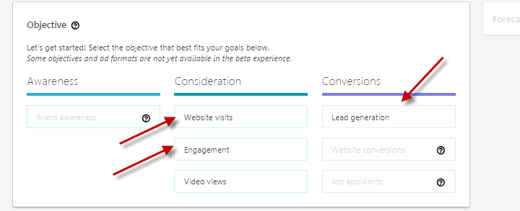
Objective: Website Visits
Audience
Select an audience:

Labels:
E.g. recruitment, etc.
Website: | This event requires registration on the event website
Share your Event (You may skip this step; your event will automatically be shared with your LinkedIn connections on LinkedIn)

Profile Language
If other than English please see below for further instructions
Locations  LinkedIn requires that you specify at least one geography. LinkedIn permits you to select your focus by state or by specific region of the state. | - Country  - State  - Region
Targeting

You may target members on LinkedIn using the categories listed below. You are not required to make selections in each category, and in some cases may be prohibited from using certain categories. Want to learn more? Please see link https://www.linkedin.com/help/lms/answer/722?accountId=507893326

Company
LinkedIn permits you to target LinkedIn members who have indicated that they work at specific company. Alternatively, you may target your ad to members who work at a certain category of company. You may make selections based on industry or company size.

You may choose to target by specific company OR by category, not both.

Note: Recruiting ads must not target an audience based on age, gender, ethnicity or any other protected class and any other targeting must be consistent with Equitable Advisors policies.
Demographics

Education

Job Experience

Interests

AD Format
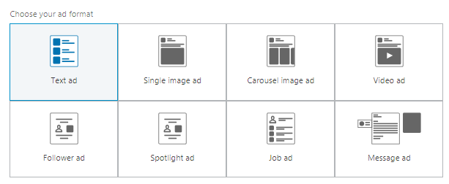
Placement
LinkedIn Audience Network
LinkedIn Audience Network gets you more reach and more results with your target audience.
How does it work?
Your ads are automatically shown to your target audience on vetted apps and sites

Budget and Schedule
Budget
- Set both a daily and total budget
- Set a daily budget
- Set a total budget
(Please select one and enter dollar amount)

Schedule
- Run campaign continuously from start date
- Set a start and end date
(Please select one and enter date)

Bid
Select the appropriate bid type for your campaign objective. If your primary goal is to get more clicks for your budget, select "Automated bid". If your primary goal is to control your effective CPC, select "Maximum CPC bid. Select the appropriate bid type for your campaign objective. If your primary goal is to get more clicks for your budget, select "Automated bid". If your primary goal is to control your effective CPM, select "Maximum CPM bid"

Maximum CPC Bid
Maximum CMC Bid
(Please select one and enter dollar amount)

Conversion tracking (Prohibited)

Body:  Use this section to further explain what you’re advertising. End with a clear call-to-action that users should take if they like your ad.  Note: Depending on the content of your particular ad, this disclosure may require customization or expansion during the advertising compliance review process. Please keep in mind that character limits and disclosure requirements may place unavoidable restrictions on the type and extent of LinkedIn Ad content that can be approved. In some cases, the disclosure may be included as part of the image. | [YOUR CONTENT HERE]  Equitable Advisors, LLC (NY, NY 212-314-4600), member FINRA, SIPC. (Equitable Financial Advisors in MI & TN) // Equitable Network, LLC. AGE-xxxxx(X/XX)(Exp.X/XX)  OR, for recruiting ads:  Equitable Advisors, LLC (Equitable Financial Advisors in MI & TN) is an equal opportunity employer. M/F/D/V. AGE-xxxxx(X/XX)(Exp.X/XX)
Image  Use this section to upload an image for your ad. The image should be related to your product/service and, to make it even more compelling, related to your title/body text for the ad as well. Choose an image that is clearly visible when it is small. | [Please submit image you intend to use along with your Ad submission to Advertising Compliance]
2. Targeting

You may target members on LinkedIn using the categories listed below. You are not required to make selections in each category, and in some cases may be prohibited from using certain categories.

Geography  LinkedIn requires that you specify at least one geography. You are limited to a total of 10. LinkedIn permits you to select your focus by state or by specific region of the state. | - Country: United States [must select]  - By State/Province:  - By City/Area:
Company  LinkedIn permits you to target LinkedIn members who have indicated that they work at specific company. Alternatively, you may target your ad to members who work at a certain category of company. You may make selections based on industry or company size.  You may choose to target by specific company OR by category, not both.  Note: Recruiting ads must not target an audience based on age, gender, ethnicity or any other protected class and any other targeting must be consistent with Equitable Advisors and Equitable Network policies. | - Company by name:  - Company by category:  Industry  - Company size:
Job Title  LinkedIn permits you to target LinkedIn members who have indicated that they have a specific job title. Alternatively, you may target your ad to members who have selected certain categories of job titles.  You may choose to target by specific job title OR by job title category, not both.  Note: Recruiting ads must not target an audience based on age, gender, ethnicity or any other protected class and any other targeting must be consistent with Equitable Advisors and Equitable Network policies. | - Specific job titles:  - Categories of job titles:  - Job function  - Seniority
LinkedIn Group  You can use this section to target people who are members of specific LinkedIn groups. | - LinkedIn Group name(s):
Gender  Note: Recruiting ads must not target an audience based on age, gender, ethnicity or any other protected class and any other targeting must be consistent with Equitable Advisors policies. | - Male  - Female

Age  Note: Recruiting ads must not target an audience based on age, gender, ethnicity or any other protected class and any other targeting must be consistent with Equitable Advisors policies. | - 18-24  - 25-34  - 35-54  - 55 +

Additional Resources

READY TO LEARN MORE? ​
Visit our program microsite: www.equitable.fmgsuite.com ​
Contact FMG Support: Equitable@fmgsuite.com or (858) 500-5479​
Contact MarTech Project Team: AdvisorMartech@Equitable.com ​
​

